# Assignment -4

Python Programming

|  |  |
| --- | --- |
| Assignment Date | 19 September 2022 |
| Student Name | Praddesh M |
| Student Roll Number | 963219104023 |
| Maximum Marks | 2 Marks |

# Question-1:

Write a python program to test a given number is prime or not.

**Solution :**

n = int(input("Enter a number: "))

f = False if n> 1:

for i in range(2, n): if (n % i) == 0:

f = True break

if f:

print(n, "is not a prime number")

else:

print(n, "is a prime number")

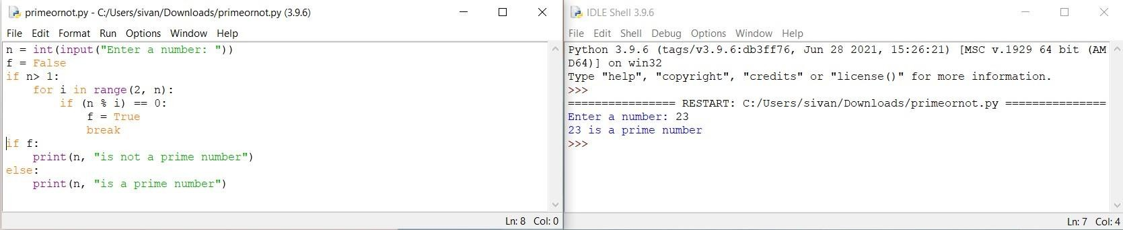

# Question-2:

Write a program to generate odd numbers from m to n using while loop

Solution :

min = int(input(" Enter any min value:")) max = int(input(" Enter any max Value : ")) X=1;

if (min < max):

while X in range(min,max+ 1):

if( X % 2 != 0):

print("{0}".format(X)) X=X+1;

else:

print("min value you've entered is greater than max value")

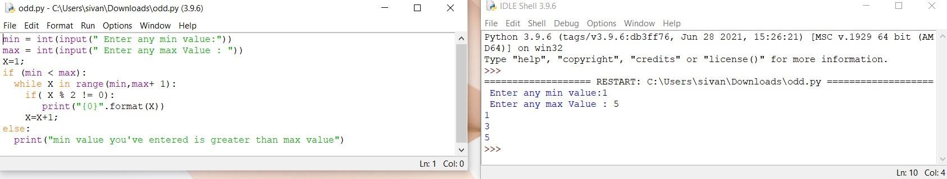

# Question-3:

Write a Python program to display prime number series upto given number.

Solution :

l = 1

u = int(input("Enter the number : "))

print("Prime numbers between",1,"and",u,"are:") for n in range(l,u + 1):

if n > 1:

for i in range(2, n): if (n%i) == 0:

break else:

print(n)

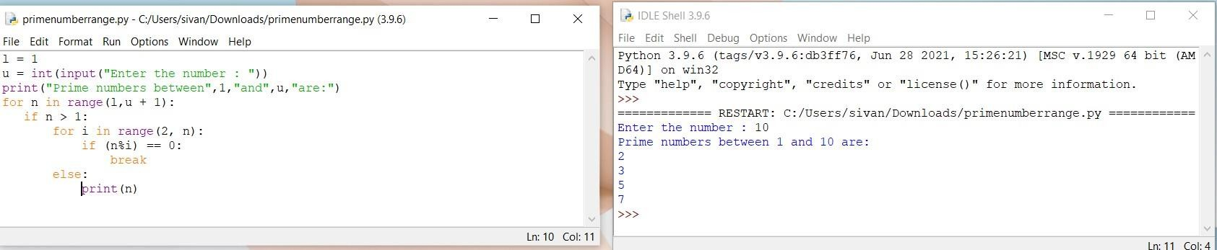

# Question-4:

Write a Python program to generate Fibonacci series.

Solution :

nt = int(input("How many terms? ")) n1, n2 = 0, 1

c = 0

if nt <= 0:

print("enter a +ve integer") elif nt == 1:

print("Fibonacci upto",nt,":") print(n1)

else:

print("Fibonacci series:") while c < nt:

print(n1)

nth = n1 + n2 n1 = n2

n2 = nth c += 1

